Contents

Wireframes for the website (Desktop Version) 2

Home Page 2

Offers Page 3

Restaurants Page 4

Adventures Page 7

Accommodation Page 8

Branches Page 9

Gallery Page 10

Contact Page 11

Wireframes (Mobile Version) 12

Home Page 12

Offers Page 16

Restaurant Page 23

Accommodation Page 26

Gallery Page 27

Branches Page 30

Contact Page 32

# Wireframes for the website (Desktop Version)

## Home Page

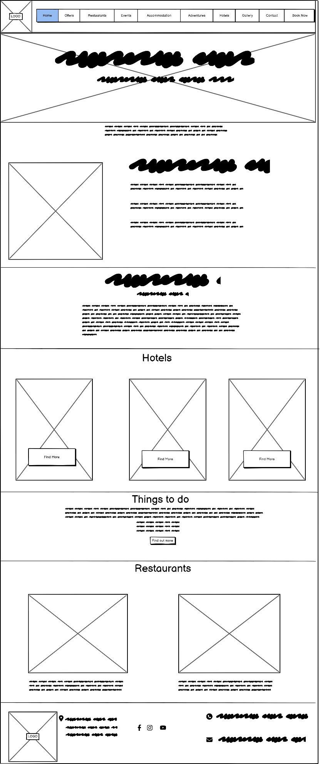

## Offers Page

## Restaurants Page

## Accommodation Page

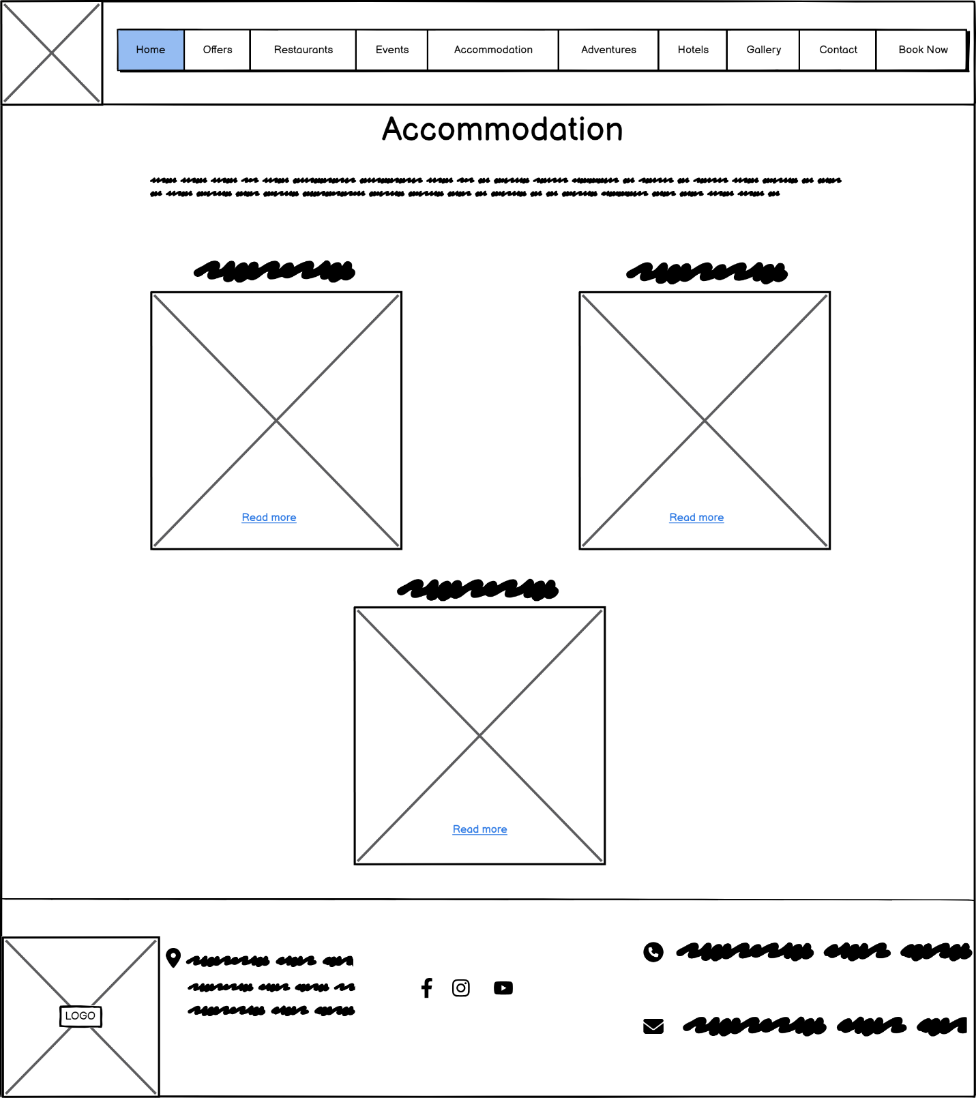

## Branches Page

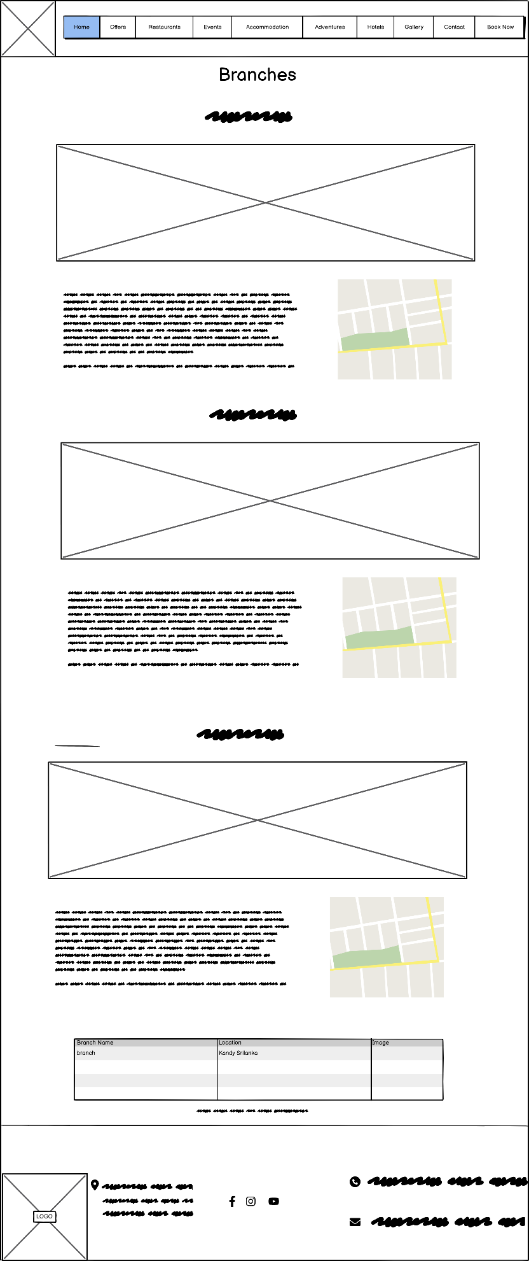

## Gallery Page

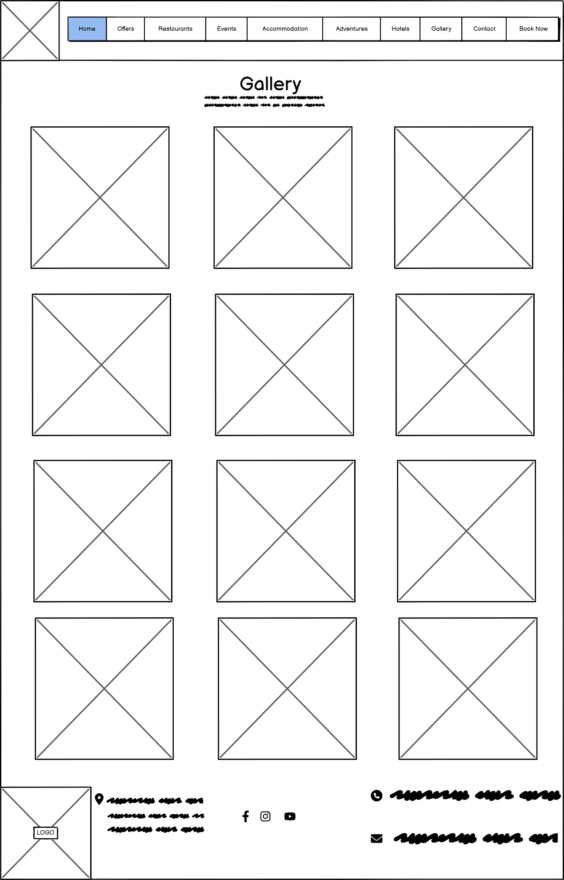

## Contact Page

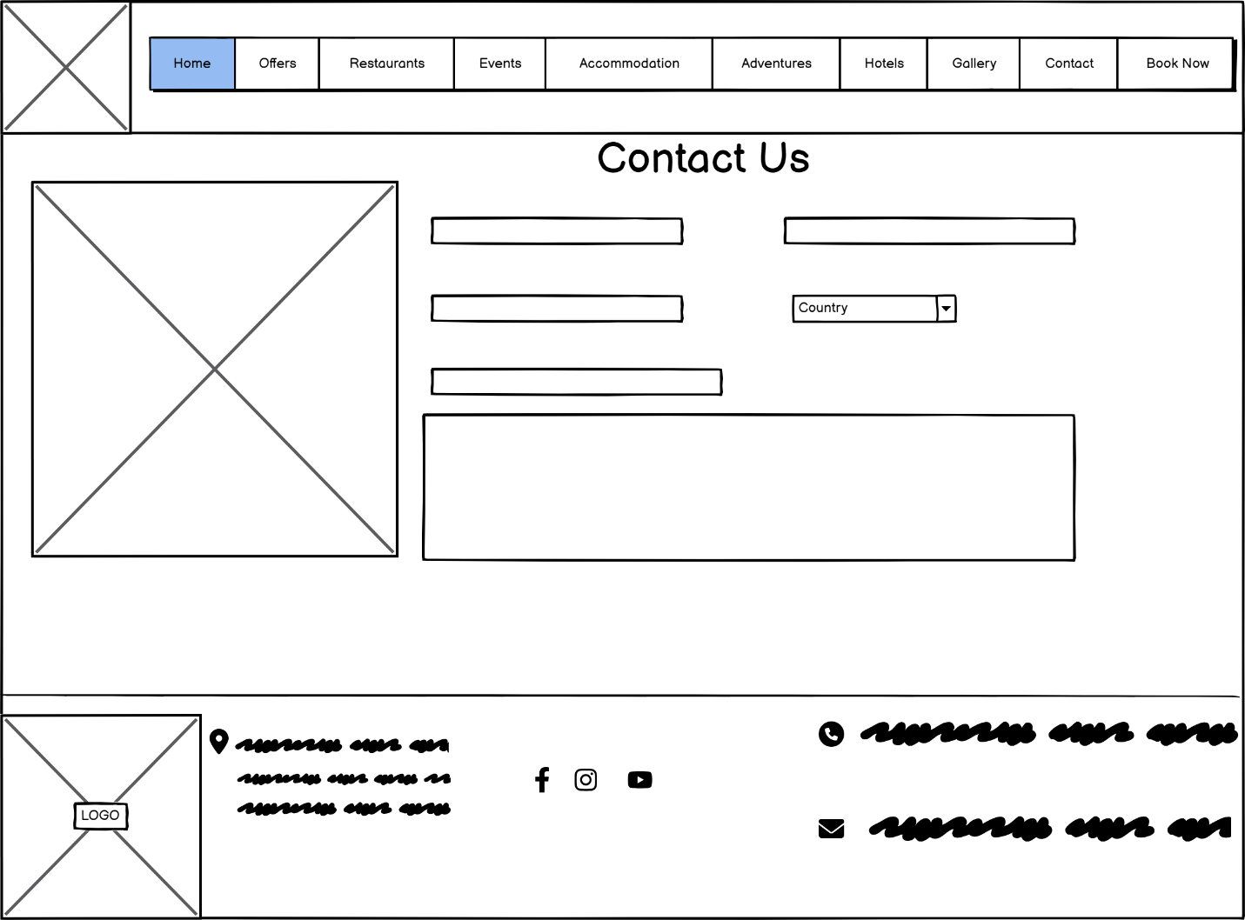

# Wireframes (Mobile Version)

## Home Page

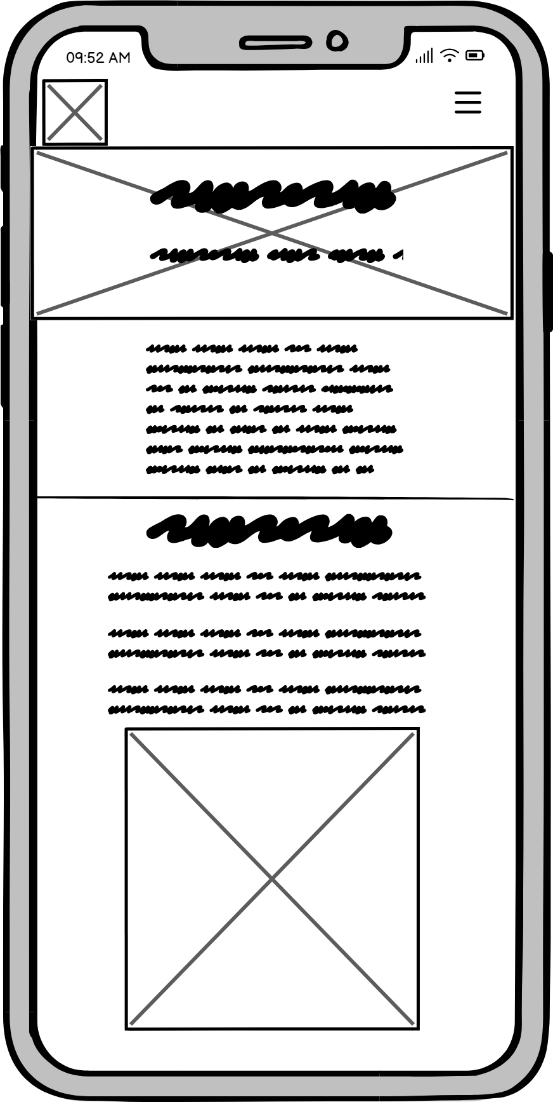

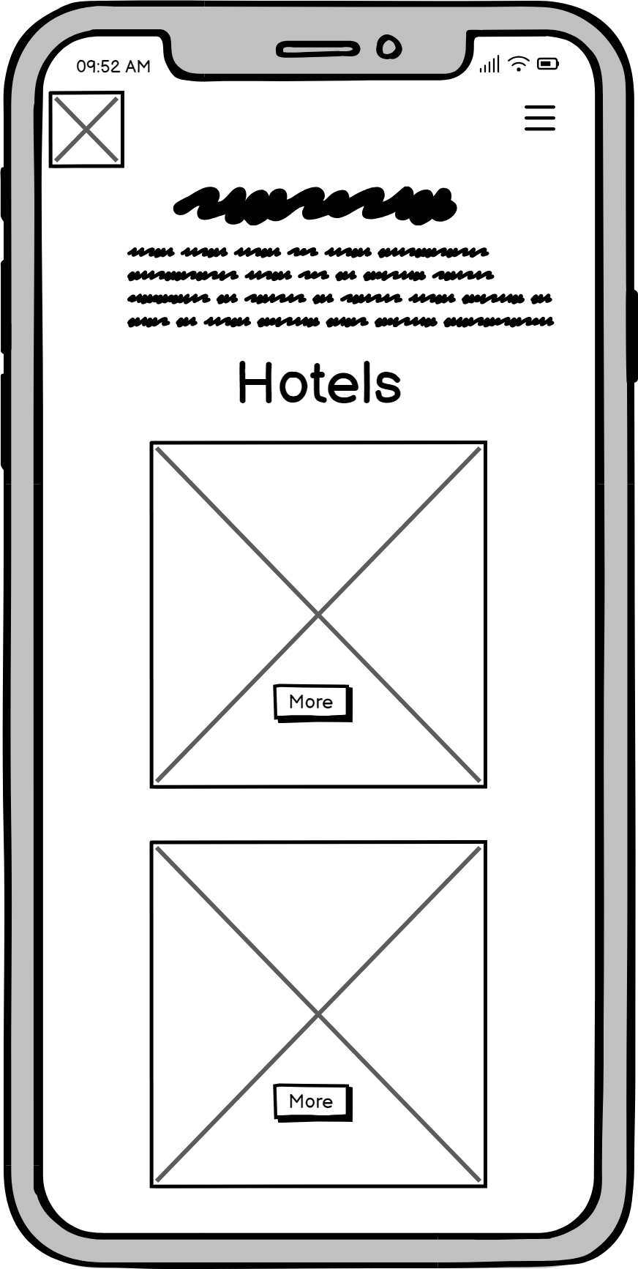

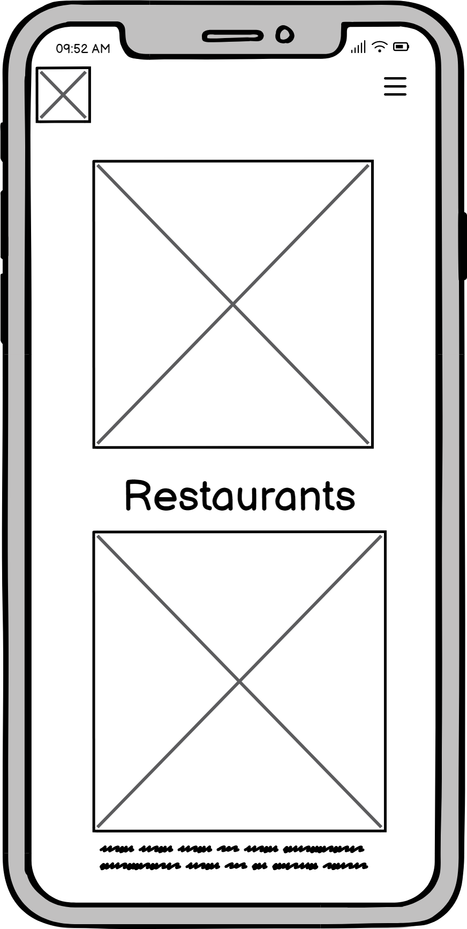

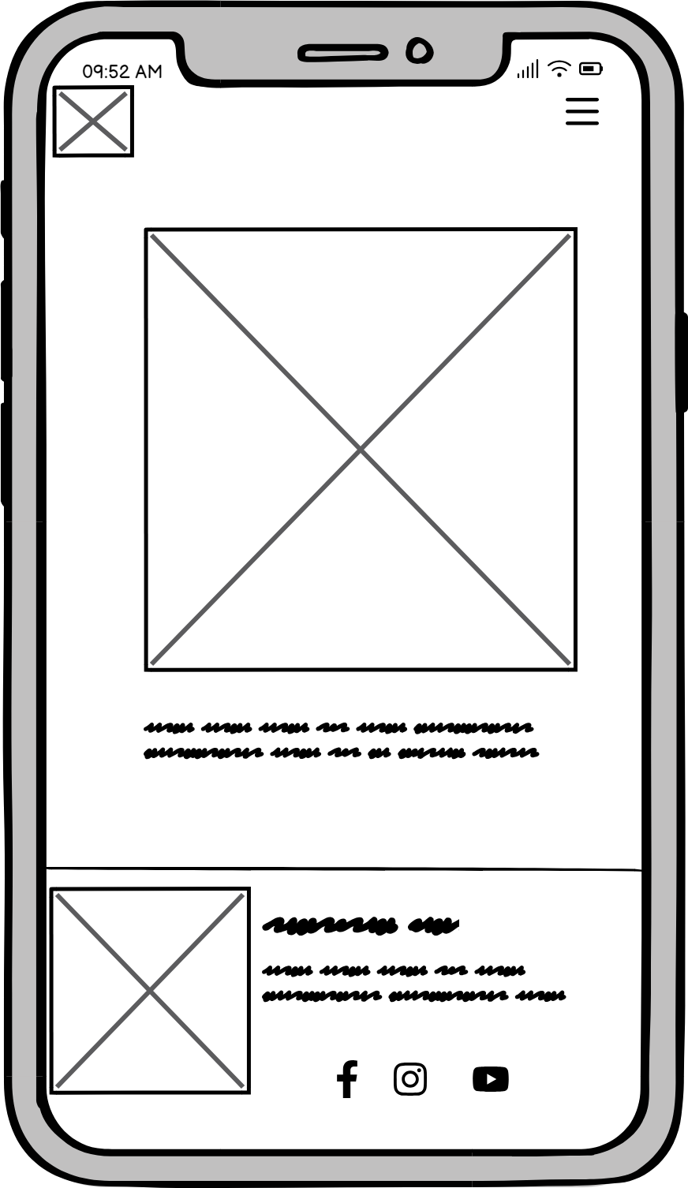

## Offers Page

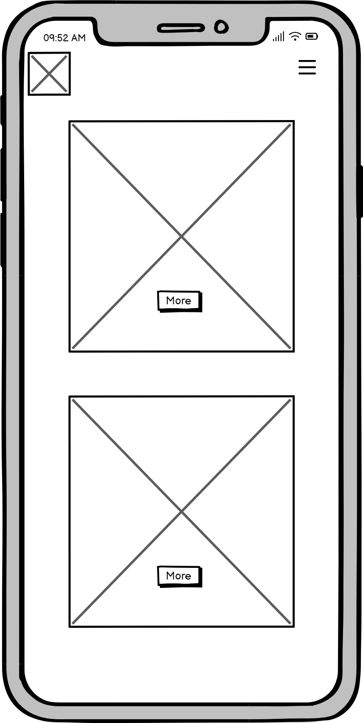

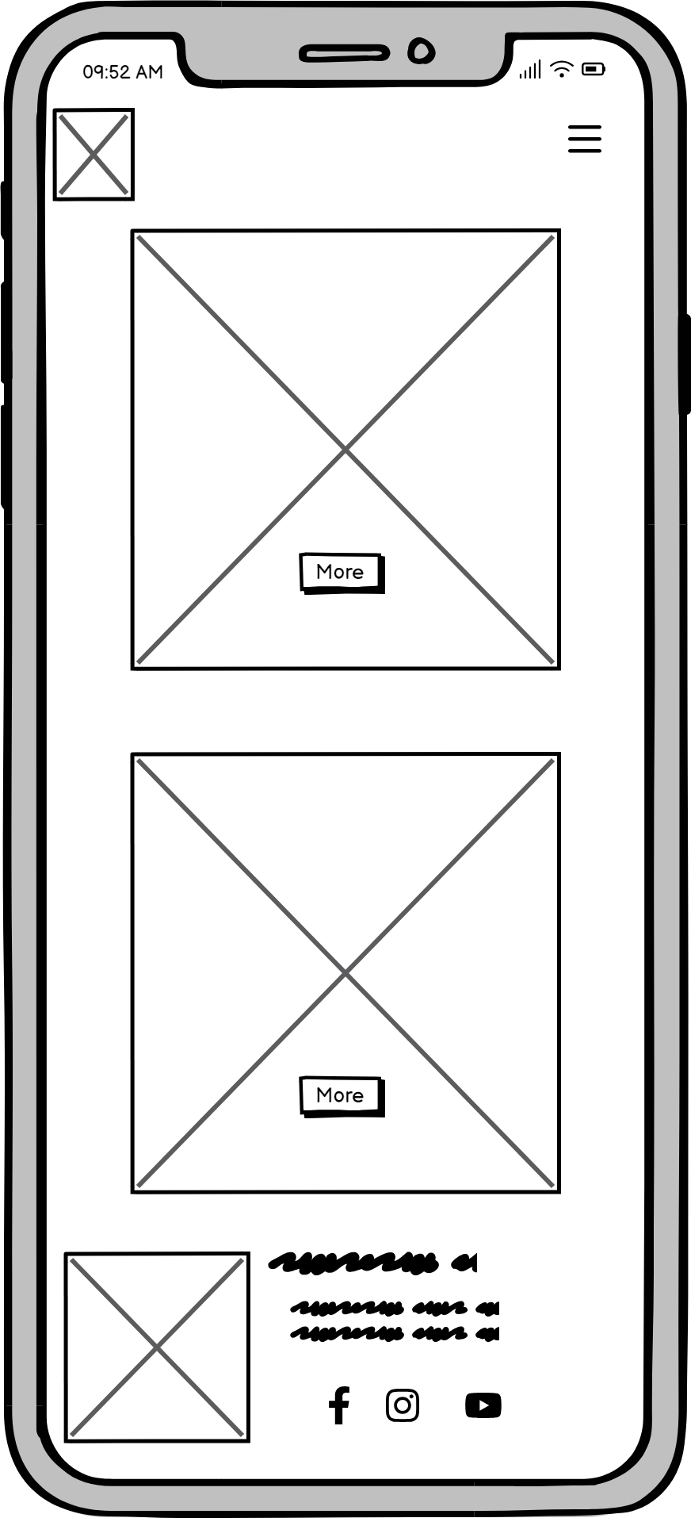

## Restaurant Page

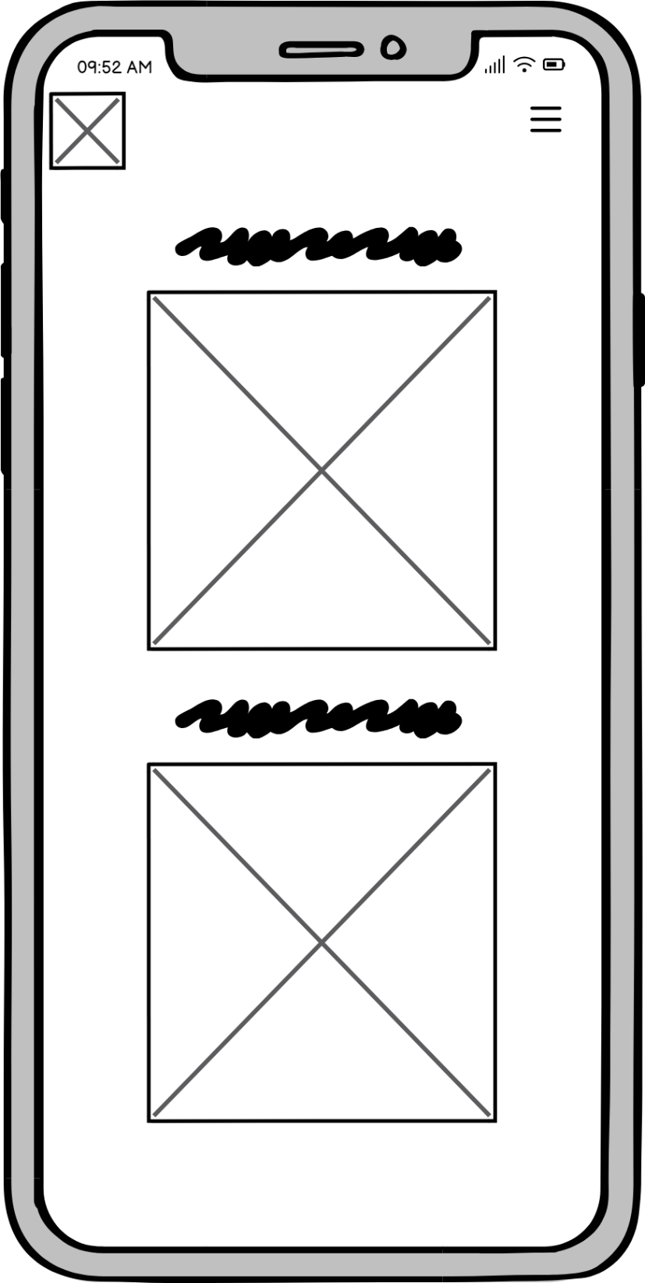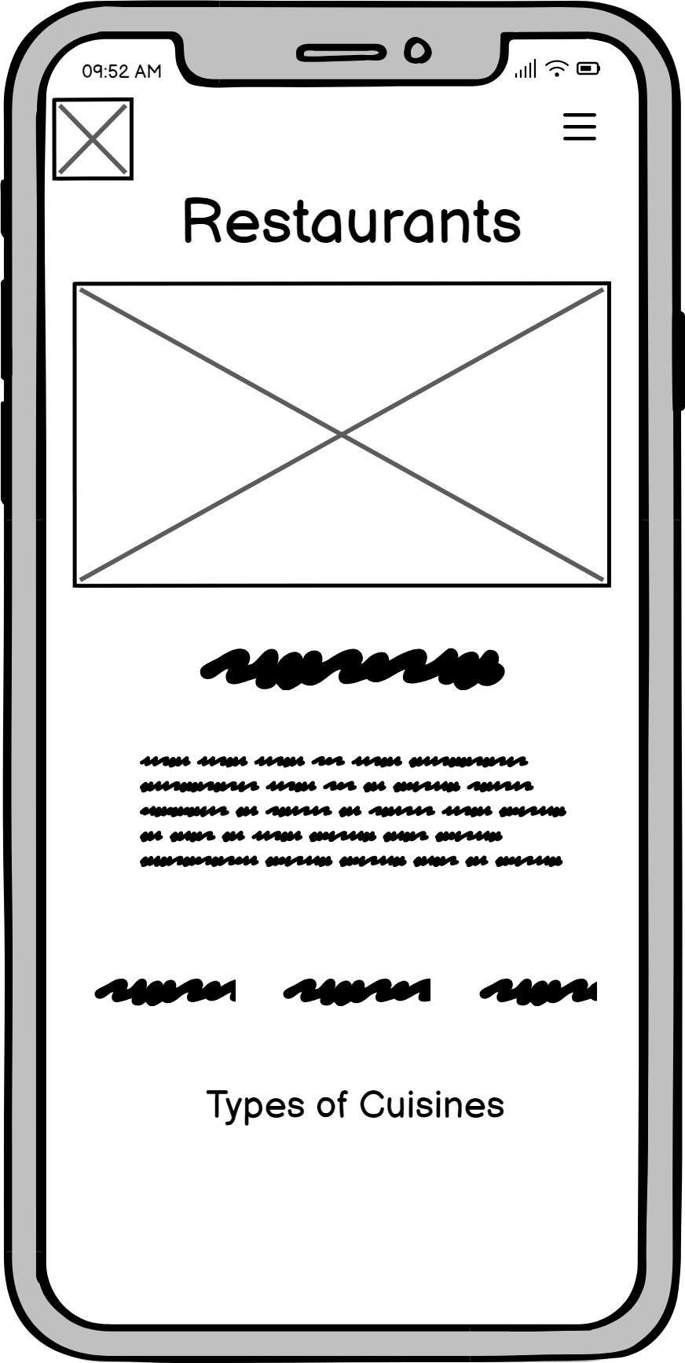

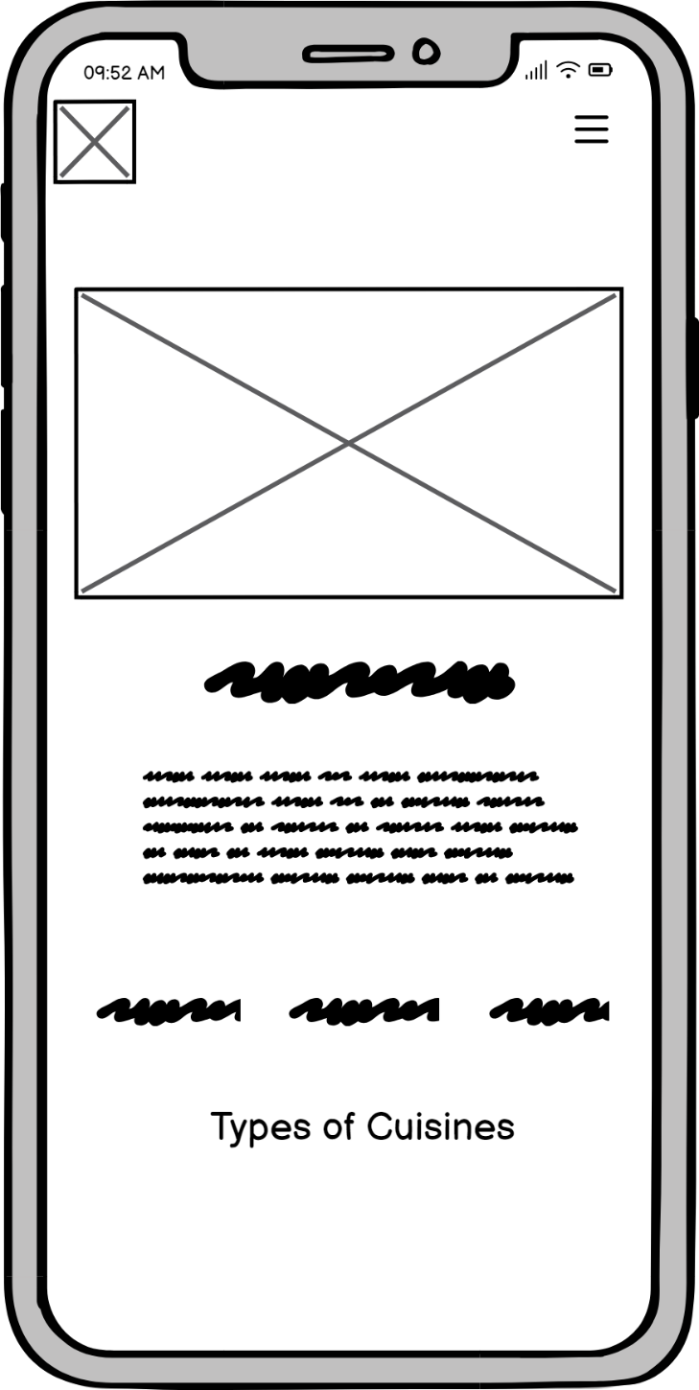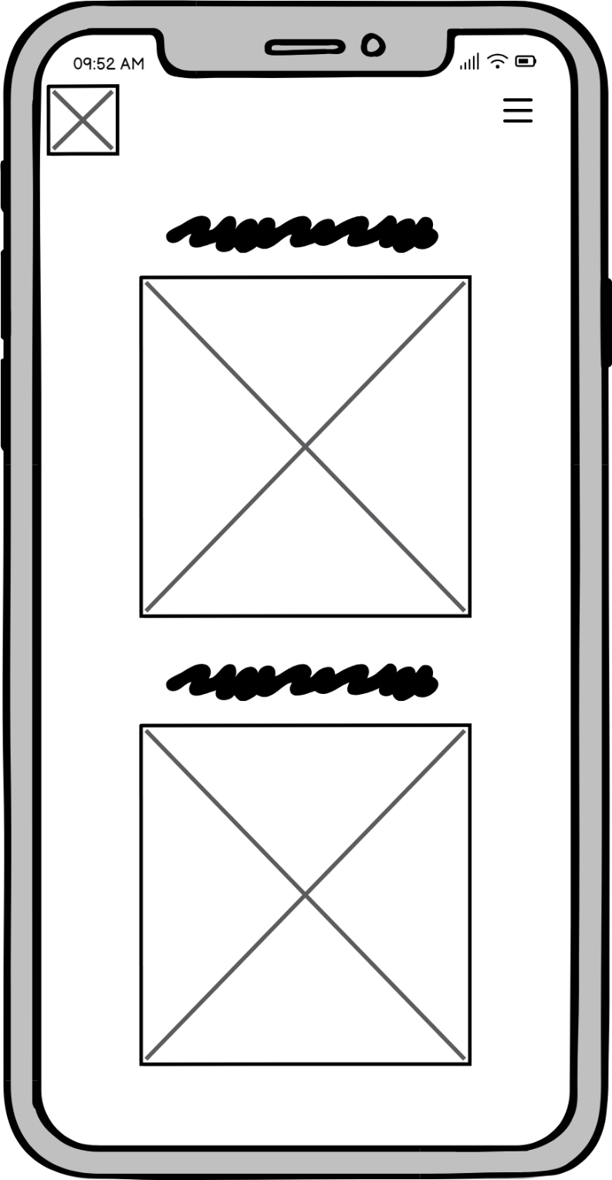

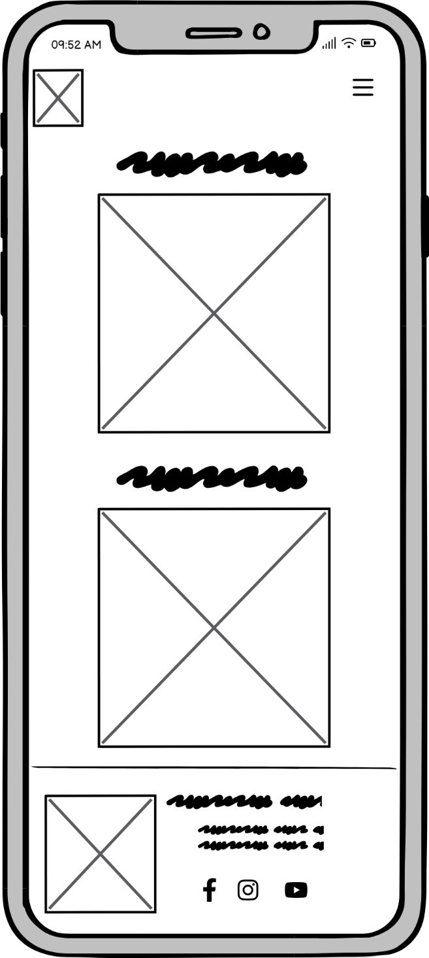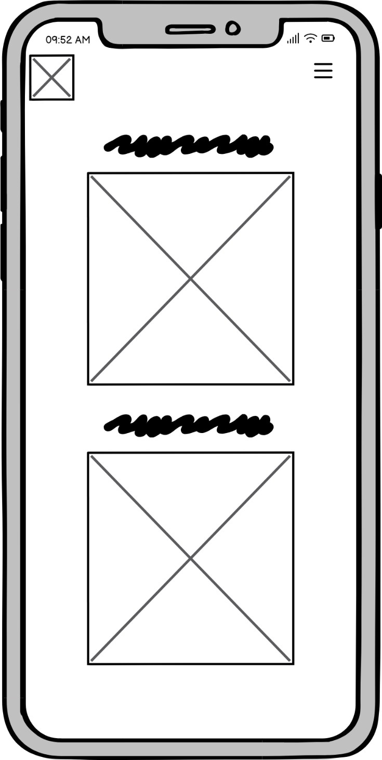

## Accommodation Page

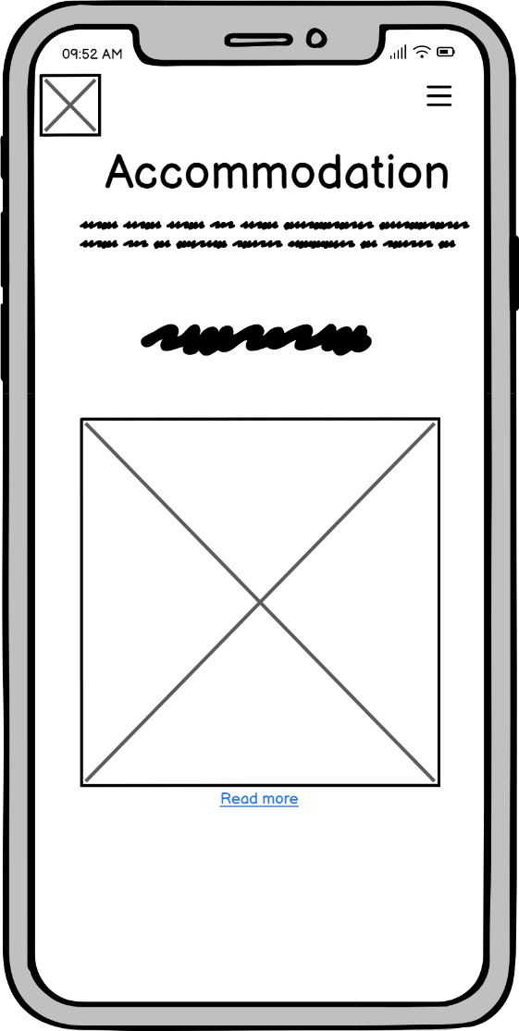

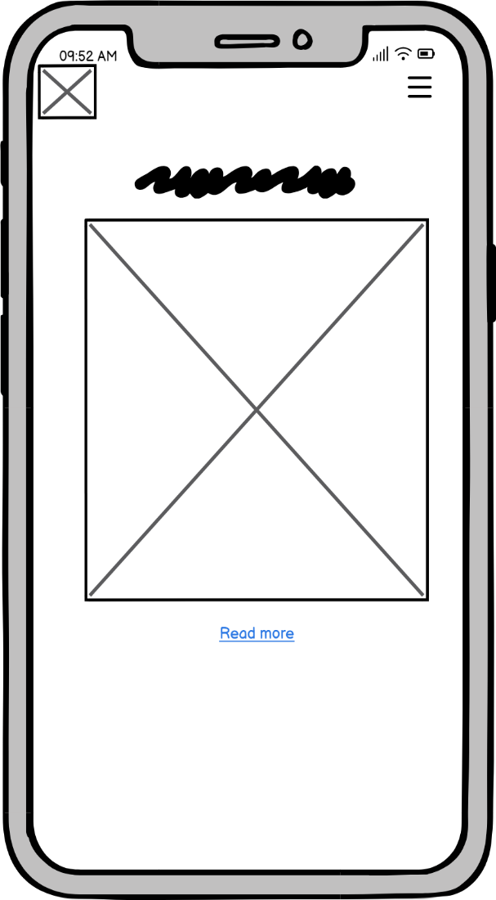

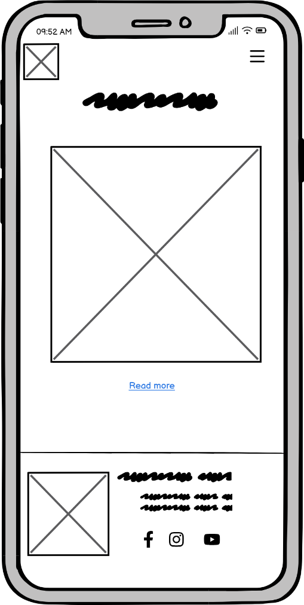

## Gallery Page

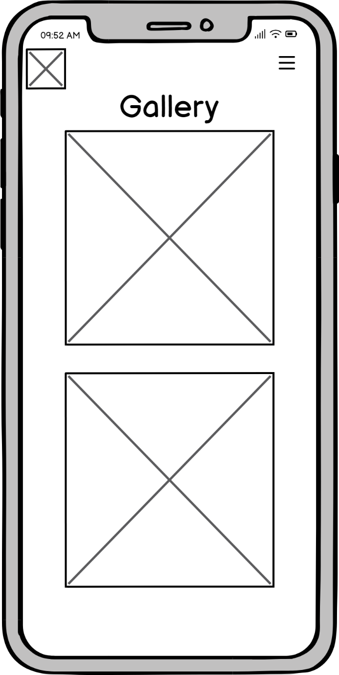

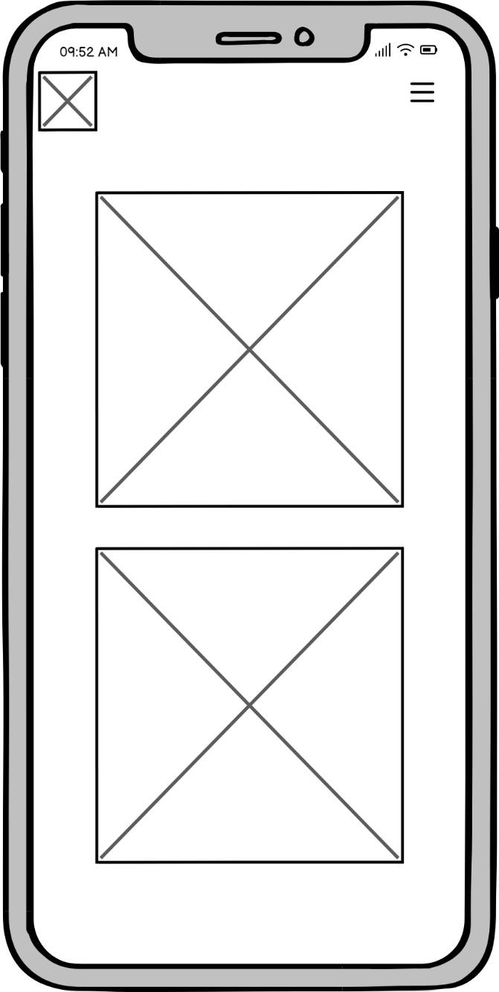

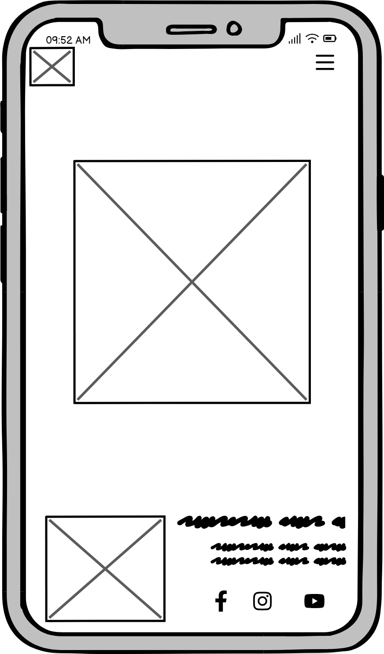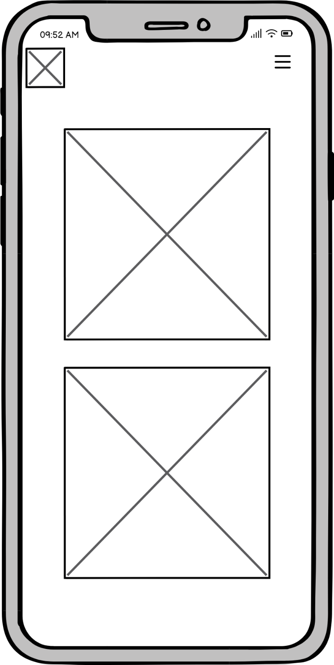

## Branches Page

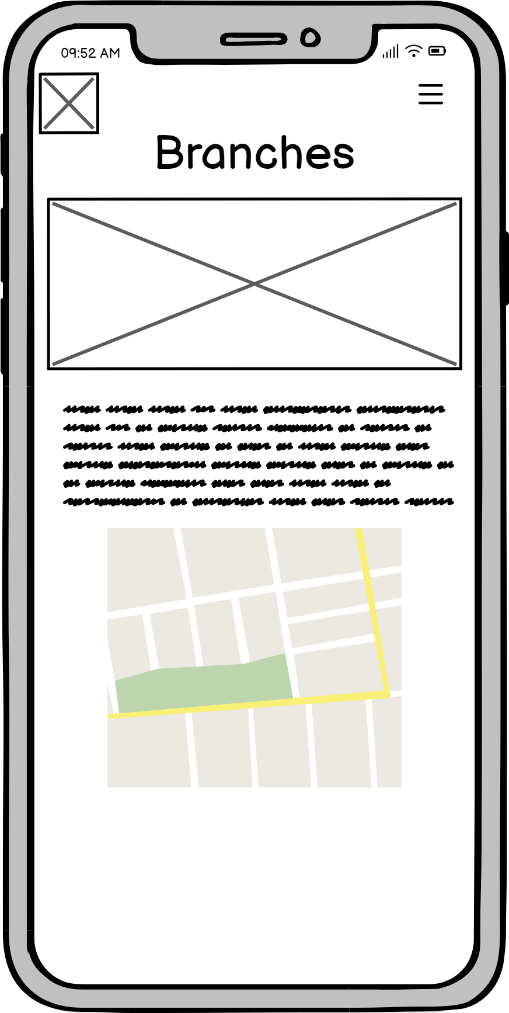

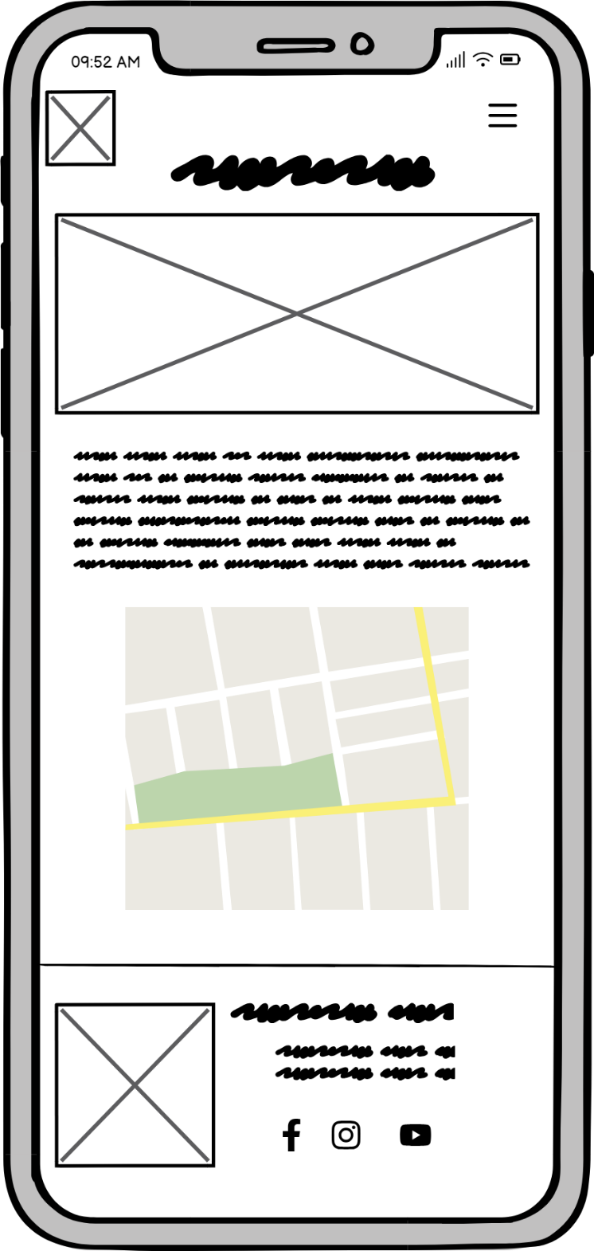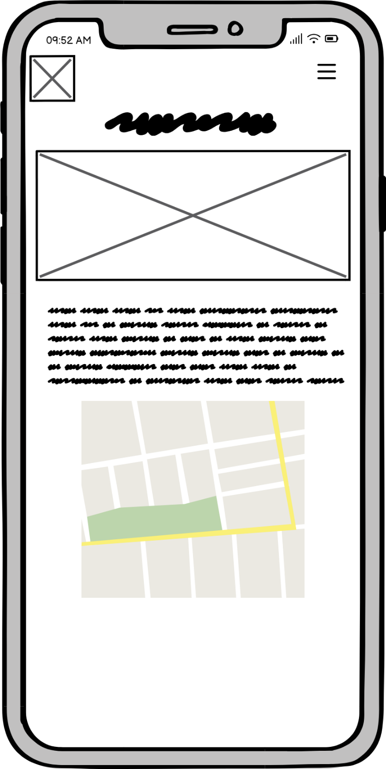

## Contact Page

